From check in to checkout our Customer processing will include constant communication with the customer in the form of emails, phone calls, and the status of the ticket at any given time.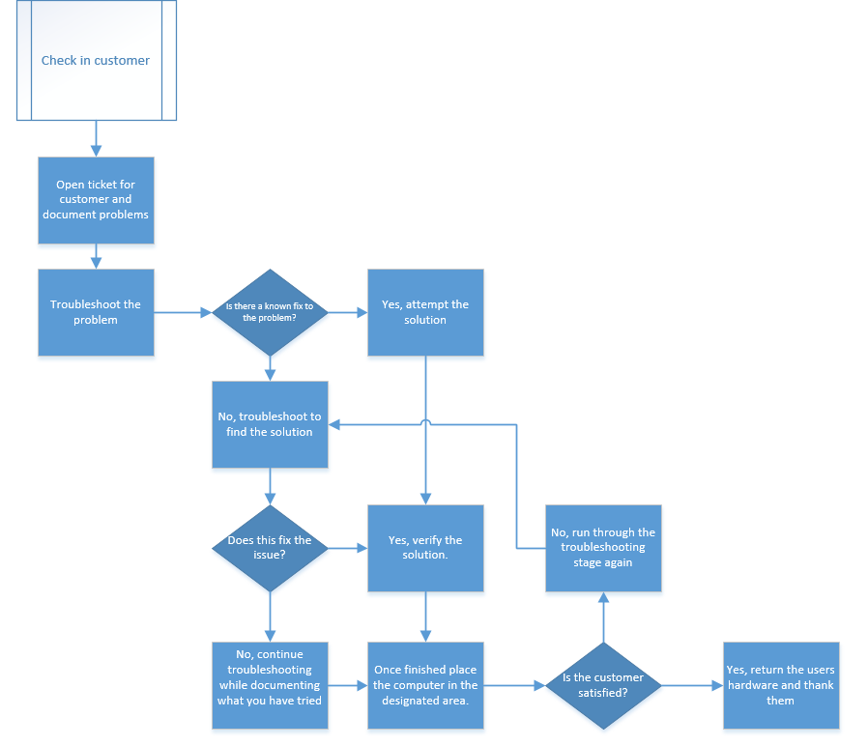

Once the customer drops off their hardware they will be assured that we will take the utmost care and provide for them with the fastest services possible.